Question 1 –

Code :

#include <stdio.h>

#include <stdlib.h>

int returncube(int n){

return n\*n\*n;

}

int main()

{

//q1

int x;

printf("enter the number : ");

scanf("%d",&x);

int s = returncube(x);

printf("the cube of number %d is : %d ",x,s);

return 0;

}

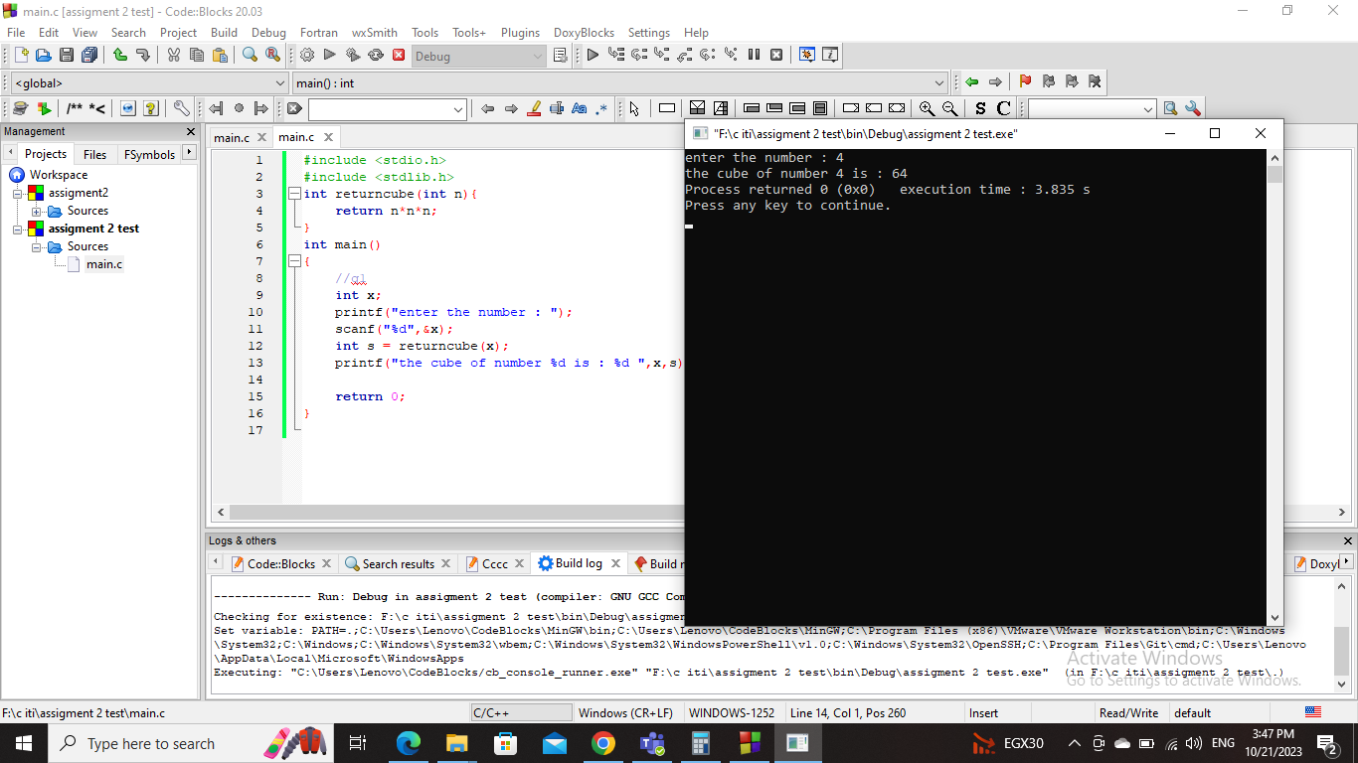Screenshots :

Question 2 -

Code :

#include <stdio.h>

#include <stdlib.h>

int checkchar(char s){

if( (s>='a' && s<='z') || (s>='A' && s<='Z')){

return 1;

}else{

return 0;

}

}

int main()

{

//q2

char c;

printf("Enter a character: ");

scanf("%c",&c);

int s = checkchar(c);

if(s == 1){

printf("%c is an alphabet. \n",c);

}else{

printf("%c is not an alphabet. \n",c);

}

return 0;

}

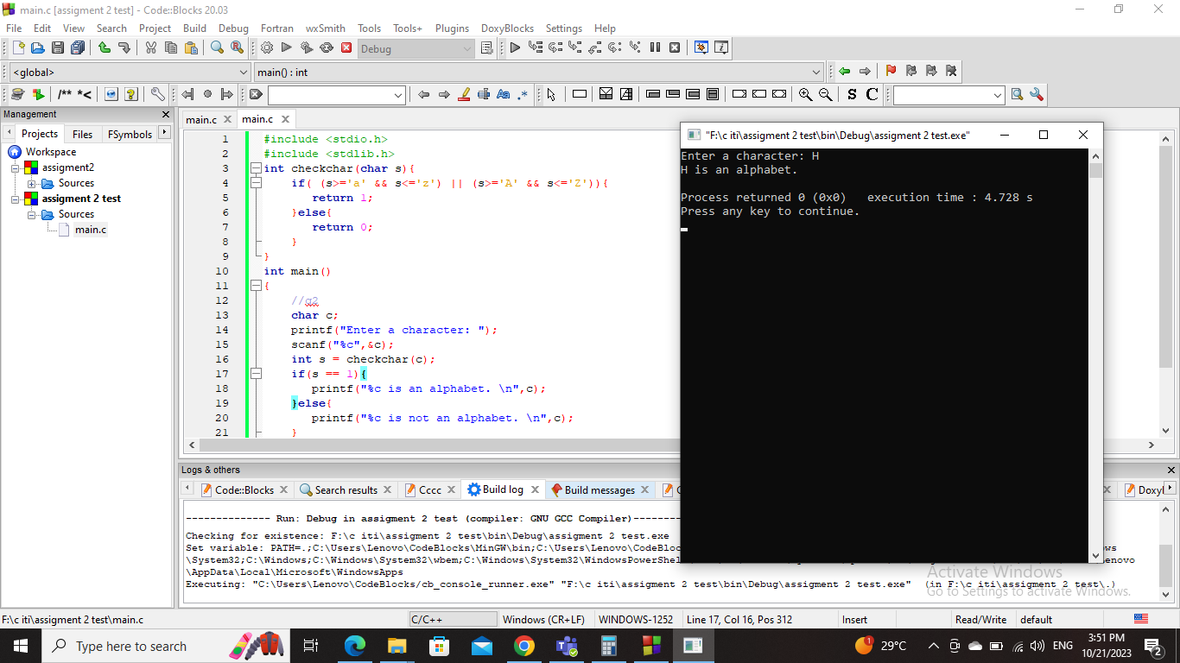Screenshot :

Question 3 –

Code :

#include <stdio.h>

#include <stdlib.h>

void checknumber(int n){

if(n == 0){

printf("not positive nor negative \n");

}else if(n > 0){

printf("positive number \n");

}else{

printf("negative number \n");

}

}

int main()

{

//q3

int number;

printf("Enter a number: ");

scanf("%d",&number);

checknumber(number);

return 0;

}

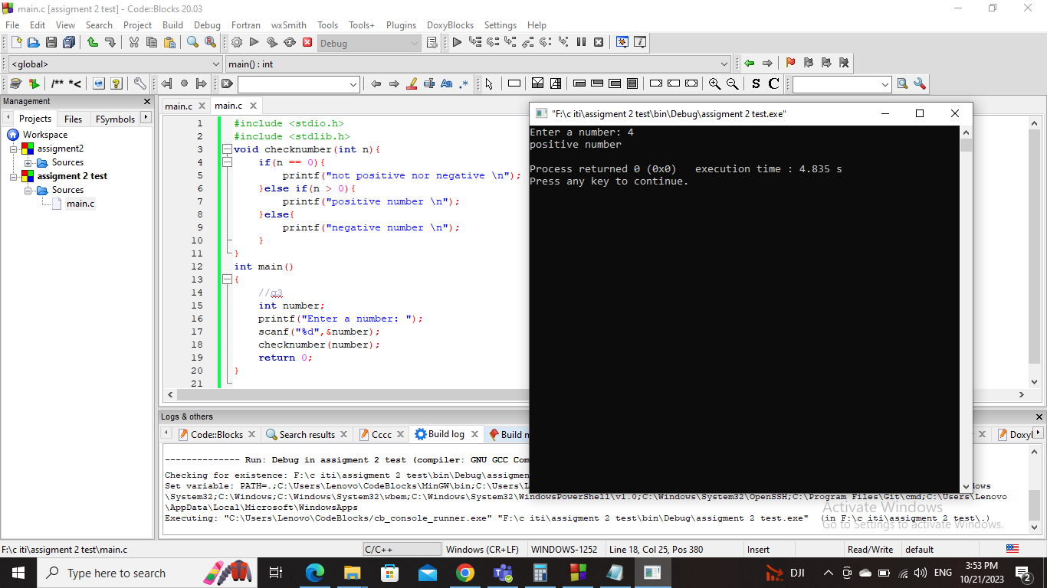Screenshot :

Question 4

#include <stdio.h>

#include <stdlib.h>

void makeoperation(int num1,int num2,char sign){

switch(sign){

case '+':

printf("the sum = %d \n",num1+num2);

break;

case '-':

printf("the sub = %d \n",num1-num2);

break;

case '\*':

printf("the multiple = %d \n",num1\*num2);

break;

case '/':

printf("the divide = %d \n",num1/num2);

break;

default:

printf("wrong operation !!\n");

break;

}

}

int main()

{

//q4

int x,y;

char z;

printf("enter the numbers : ");

scanf("%d %d",&x,&y);

printf("enter the operation sign : ");

scanf(" %c",&z);

makeoperation(x,y,z);

return 0;

}

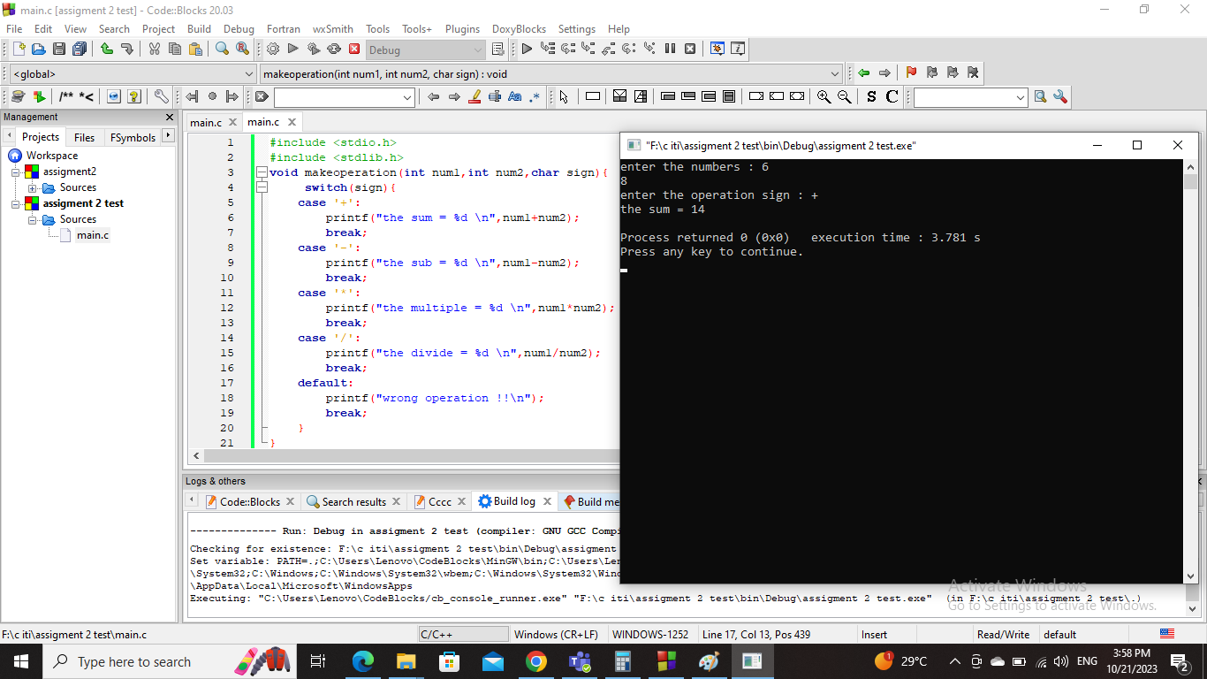Screenshot :

Question 5 –

Code :

#include <stdio.h>

#include <stdlib.h>

void checkevenorodd(int n){

if(n == 0){

printf("not even not odd .. \n");

}else if(n %2 == 0){

printf("0 \n");

}else{

printf("1 \n");

}

}

int main()

{

//q5

int number;

printf("enter the number : ");

scanf("%d",&number);

checkevenorodd(number);

return 0;

}

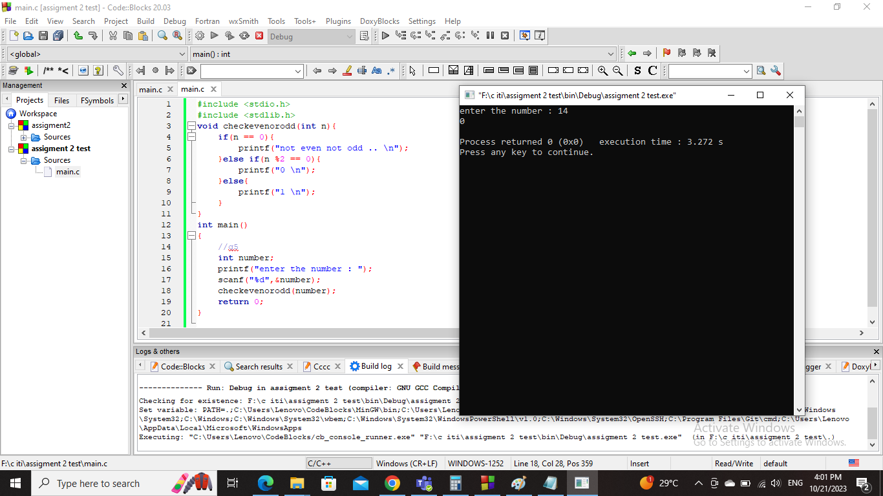screenshot :

Question 6 –

Code :

#include <stdio.h>

#include <stdlib.h>

void convertchar(char x){

int s = (int)x;

printf("%c \n",s-32);

}

int main()

{

//q6

char c;

printf("enter the character : ");

scanf("%c",&c);

convertchar(c);

return 0;

}

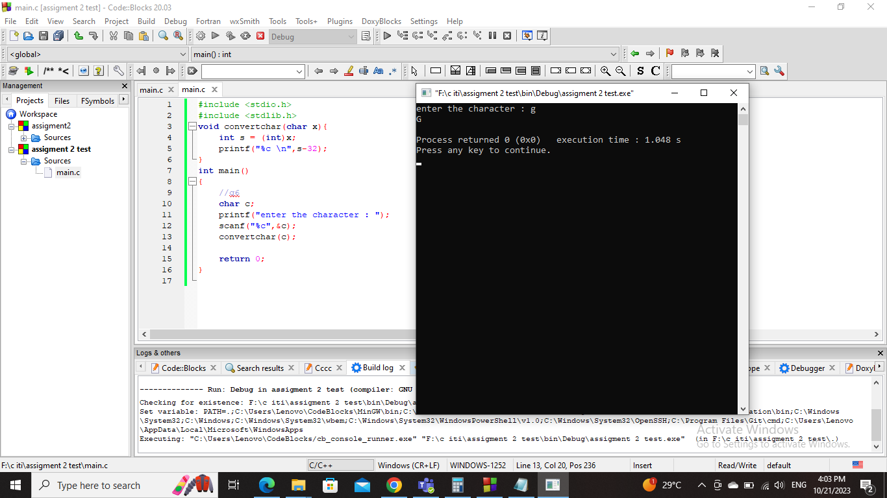Screenshot :

Question 7 –

Code :

#include <stdio.h>

#include <stdlib.h>

int checkmultiplication(int n1,int n2){

if(n1 % n2 == 0){

return 1;

}else{

return 0;

}

}

int main()

{

//q7

int num1,num2;

printf("enter the numbers : ");

scanf("%d %d",&num1,&num2);

int result = checkmultiplication(num1,num2);

if(result == 1){

printf("number %d is multiple of number %d \n",num1,num2);

}else{

printf("number %d is not multiple of number %d \n",num1,num2);

}

return 0;

}

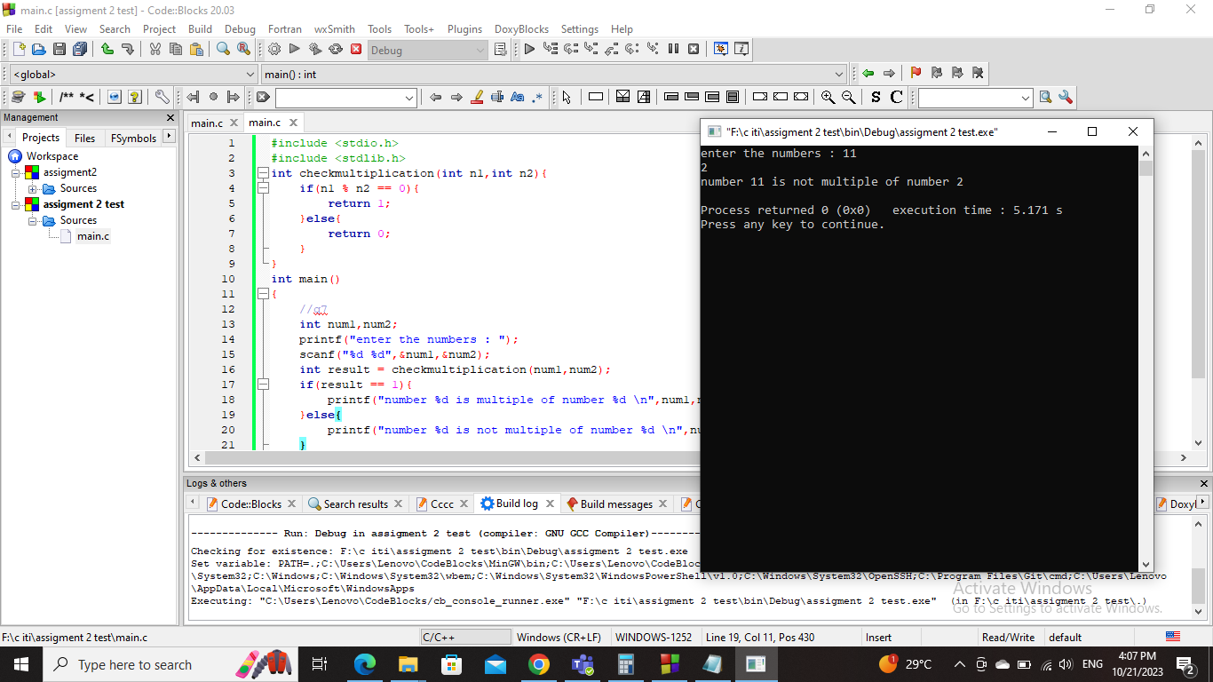Screenshot :

Question 8 –

Code :

#include <stdio.h>

#include <stdlib.h>

void printintervals(int num1,int num2){

if(num1 == num2){

printf("the numbers are equal .. enter two different number \n");

}else{

if(num1 > num2){

for(int i=num2 ; i<=num1 ; i++){

int flag = 0;

if (i == 0 || i == 1){

flag = 1;

}

for (int j = 2; j <= i / 2; ++j) {

if (i % j == 0) {

flag = 1;

break;

}

}

if (flag == 0){

printf("%d \n",i);

}

}

}else{

for(int i=num1 ; i<=num2 ; i++){

int flag = 0;

if (i == 0 || i == 1){

flag = 1;

}

for (int j = 2; j <= i / 2; ++j) {

if (i % j == 0) {

flag = 1;

break;

}

}

if (flag == 0){

printf("%d \n",i);

}

}

}

}

}

int main()

{

//q8

int n1,n2;

printf("enter the numbers : ");

scanf("%d %d",&n1,&n2);

if(n1 < 0 || n2 < 0){

printf("enter positive numbers \n");

}else{

printintervals(n1,n2);

}

return 0;

}

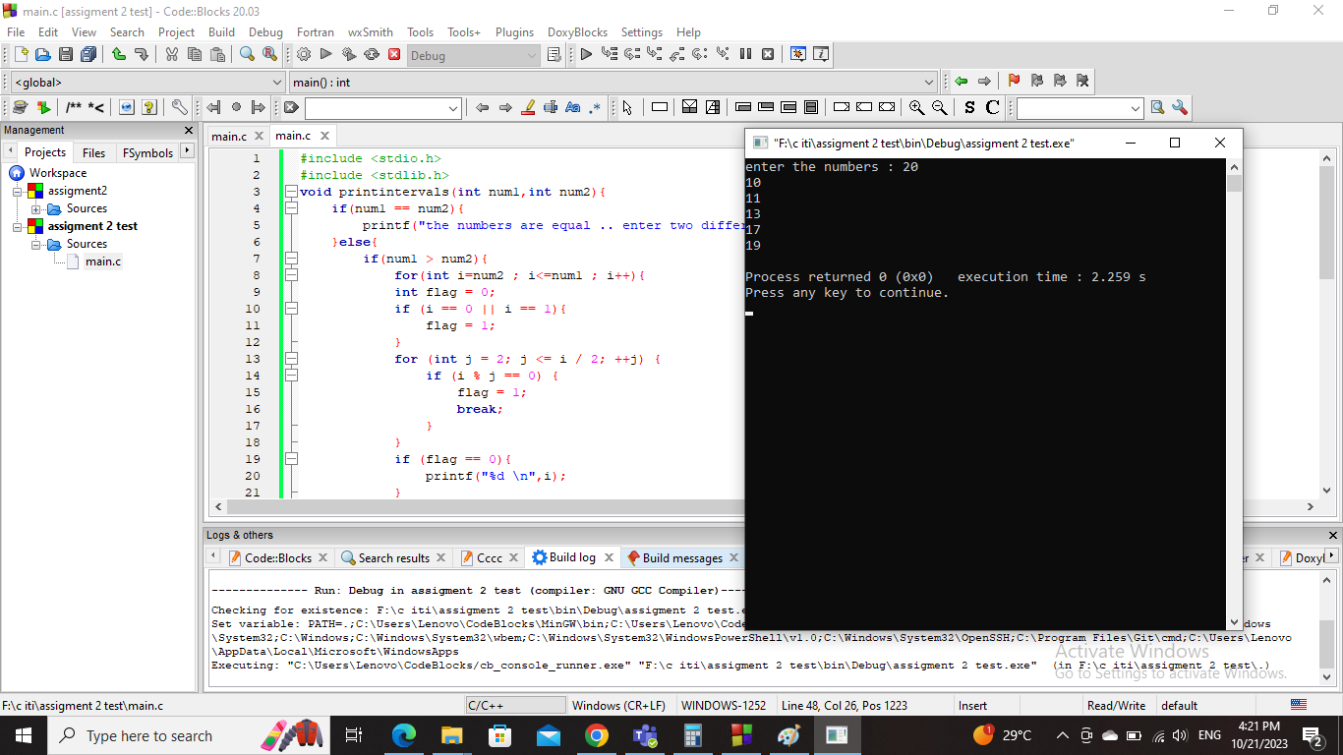Screenshot :

Question 9 –

Code :

#include <stdio.h>

#include <stdlib.h>

void swapping(int num1,int num2){

printf("before swapping first number = %d and second number = %d \n",num1,num2);

int swap;

swap = num1;

num1 = num2;

num2 = swap;

printf("after swapping first number = %d and second number = %d \n",num1,num2);

}

int main()

{

//q9

int n1,n2;

printf("enter the numbers : ");

scanf("%d %d",&n1,&n2);

swapping(n1,n2);

return 0;

}

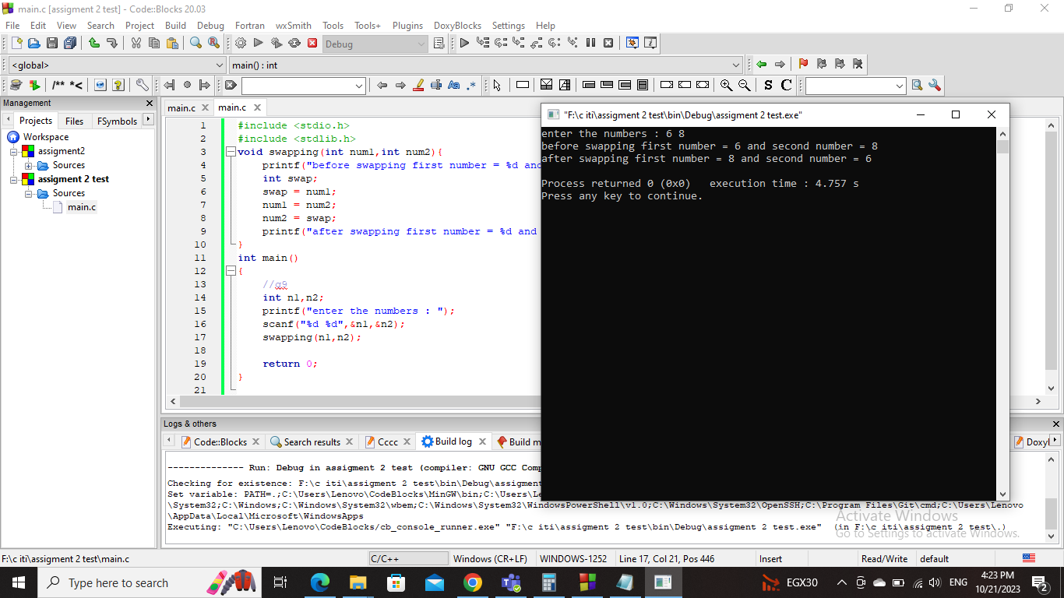Screenshot :

Question 10 –

Code :

#include <stdio.h>

#include <stdlib.h>

int counthole(int number){

int hole=0;

while(number!= 0){

int s = number%10;

if(s == 0 || s == 4 || s == 6 || s == 9){

hole+= 1;

}else if(s == 8){

hole+= 2;

}else{

hole+= 0;

}

number/= 10;

}

return hole;

}

int main()

{

//q10

int x;

printf("enter the number : ");

scanf("%d",&x);

int result = counthole(x);

printf("the number of holes = %d \n",result);

return 0;

}

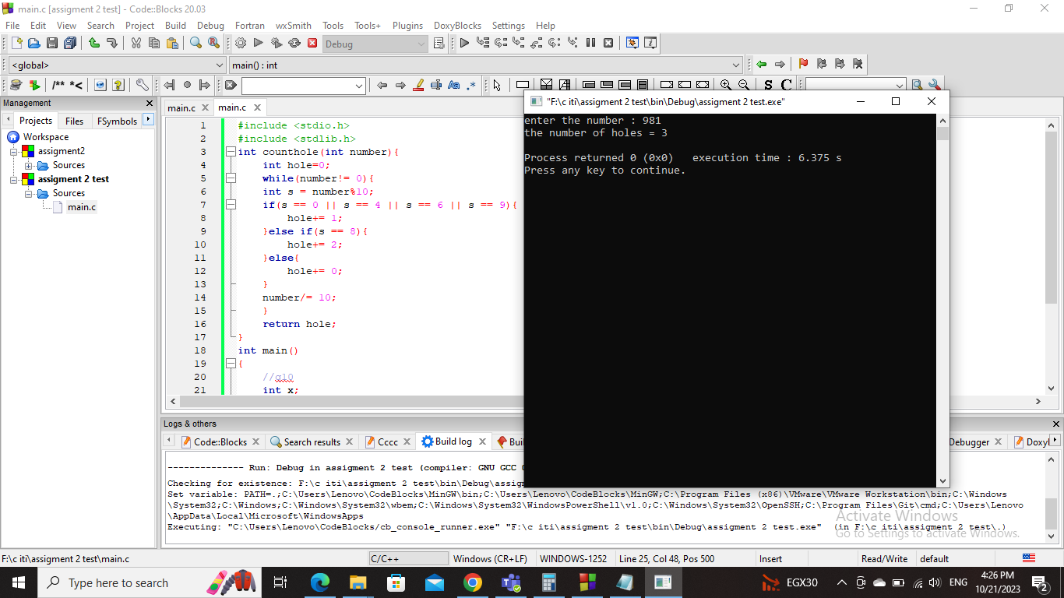Screenshot :

Question 11 –

Code :

#include <stdio.h>

#include <stdlib.h>

int checkpower(int number){

int flag=0;

if(number == 0){

return 1;

}else if(number == 1){

return 0;

}else if(number > 1){

while(number!= 1 && flag!= 1){

if(number %2 == 0){

number= number/2;

}else{

flag = 1;

}

}

if(flag == 1){

return 0;

}else{

return 1;

}

}

}

int main()

{

//q11

int n;

printf("enter the number : ");

scanf("%d",&n);

int result = checkpower(n);

if(n < 0){

printf("enter number more than 0 \n");

}else{

printf("%d \n",result);

}

return 0;

}

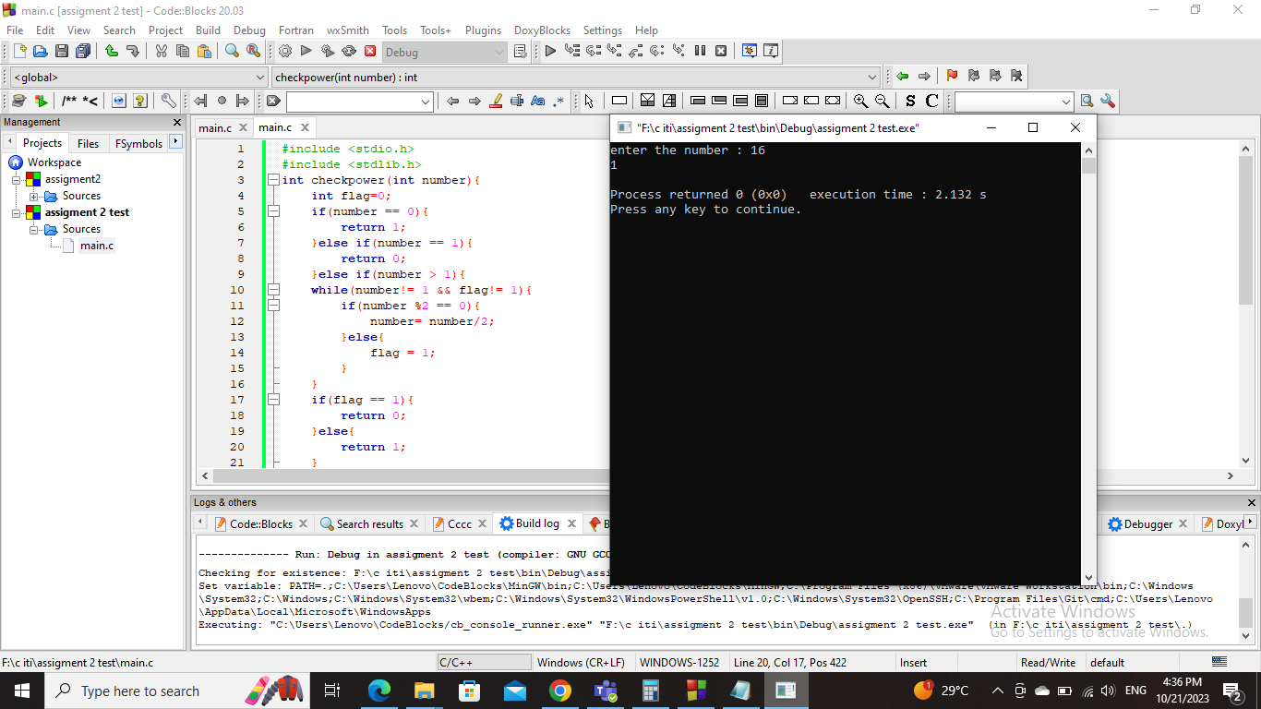Screenshot :

Question 12 –

Code :

#include <stdio.h>

#include <stdlib.h>

int calculateheating(int number){

if(number >=0 && number <=30){

return 7;

}else if(number >30 && number <= 60){

return 5;

}else if(number >60 && number <=90){

return 3;

}else if(number >90 && number <=100){

return 1;

}else{

return 0;

}

}

int main()

{

//q12

int n;

printf("enter the number : ");

scanf("%d",&n);

int result = calculateheating(n);

printf("%d \n",result);

return 0;

}

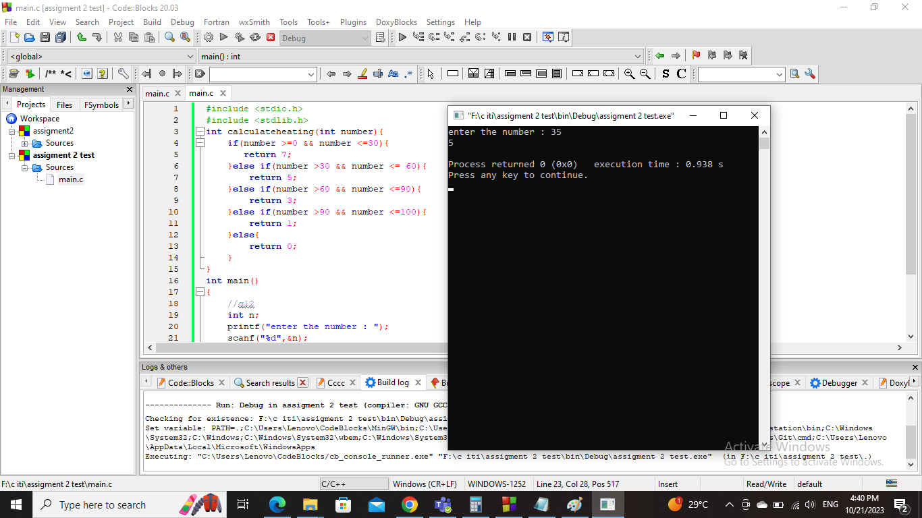Screenshot :

Question 13 –

Code :

#include <stdio.h>

#include <stdlib.h>

float printfloor(float n1,float n2){

return n1+n2;

}

int main()

{

//q13

float num1,num2;

printf("enter the 2 numbers : ");

scanf("%f %f",&num1,&num2);

float result2 = printfloor(num1,num2);

printf("the result = %d \n",(int)result2);

return 0;

}

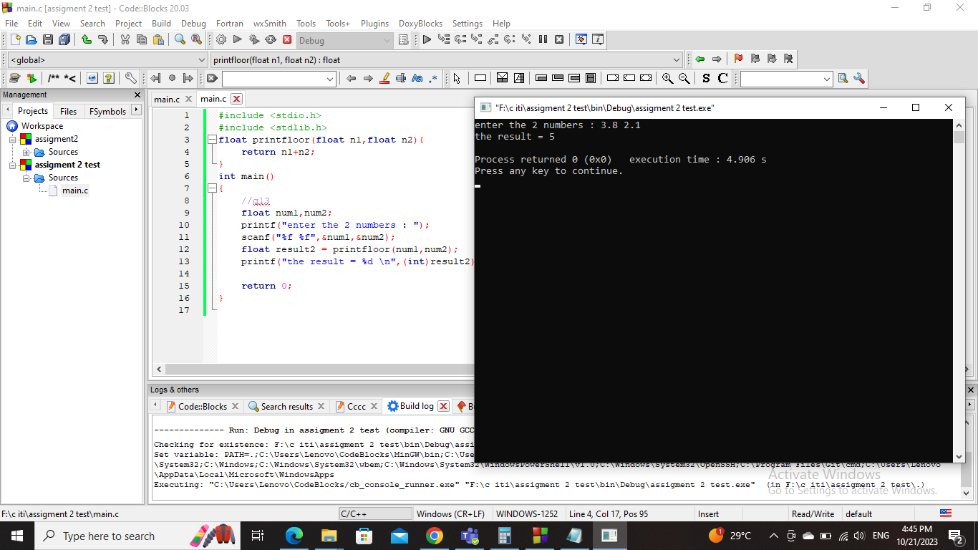Screenshot :

Question 14 –

Code :

#include <stdio.h>

#include <stdlib.h>

void calculatefibonacci(int x,int term1,int term2,int next){

for (int i = 3; i <= x; ++i) {

printf("%d, ", next);

term1 = term2;

term2 = next;

next = term1 + term2;

}

}

int main()

{

//q14

int n;

printf("Enter the number of terms: ");

scanf("%d", &n);

int t1 = 0, t2 = 1;

int nextTerm = t1 + t2;

printf("Fibonacci Series: %d, %d, ", t1, t2);

calculatefibonacci(n,t1,t2,nextTerm);

return 0;

}

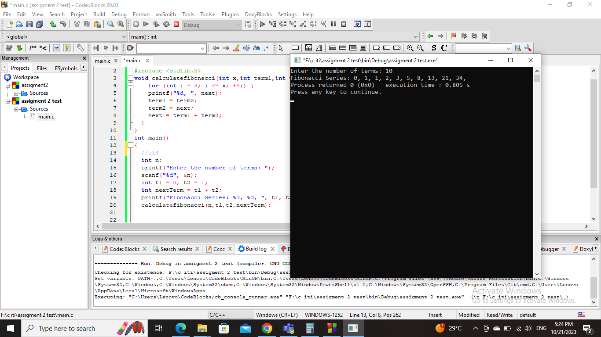Screenshot :